**DYNAMIXEL AX series**

**Introduction**

The Dynamixel series robot actuator is a smart, modular actuator that incorporates a gear reducer, a precision DC motor and a control circuitry with networking functionality, all in a single package. Despite its compact size, it can produce high torque and is made with high quality materials to provide the necessary strength and structural resilience to withstand large external forces. It also has the ability to detect and act upon internal conditions such as changes in internal temperature or supply voltage. The Dynamixel series robot actuator has many advantages over similar products.

Using the actuator of this series , Position and speed can be controlled with a resolution of 1024 steps.

The Dynamixel series robot actuator can alert the user when parameters deviate from user defined ranges (e.g. torque, voltage, etc) and can also handle the problem automatically.

Wiring is easy with daisy chain connection, and it support communication speeds up to 1M BPS.

This is the Specification of the Dynamixel AX-18A :-

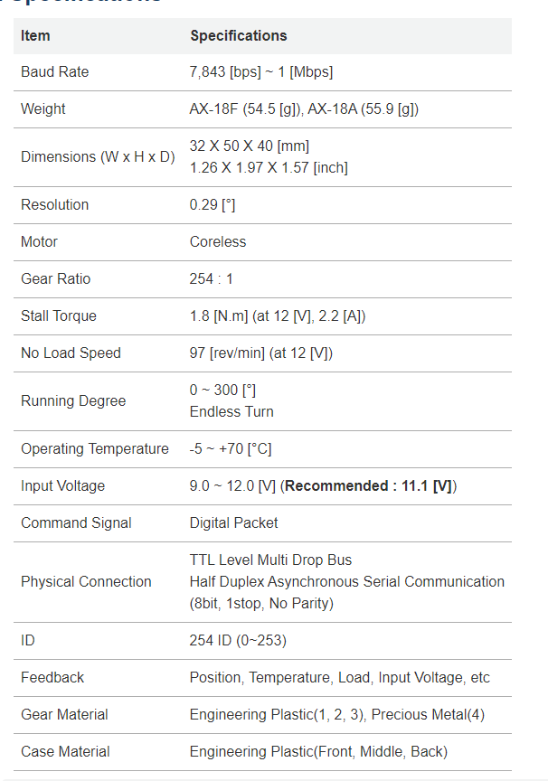

The Physical Photo of the Dynamixel series is as follows :-

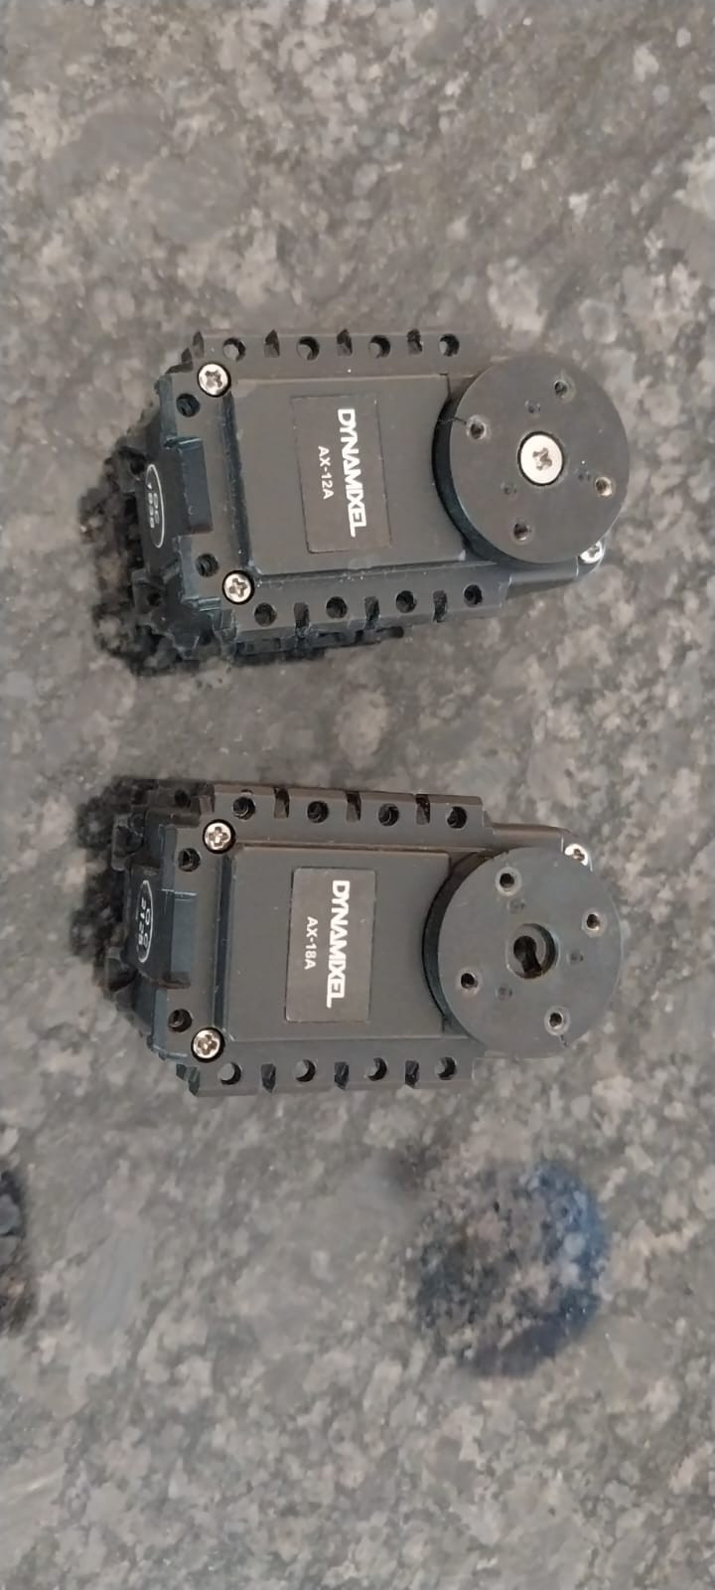

**Pin Assignment :-**

The connector pin assignments are as the following. The two connectors on the Dynamixel are connected pin to pin, thus it can be operated with only one connector attached.

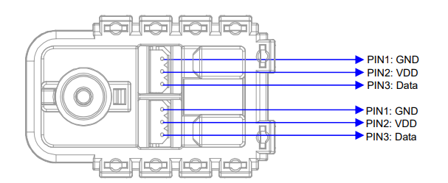

Connect the actuators pin to pin as shown below. Many actuators can be controlled with a single bus in this manner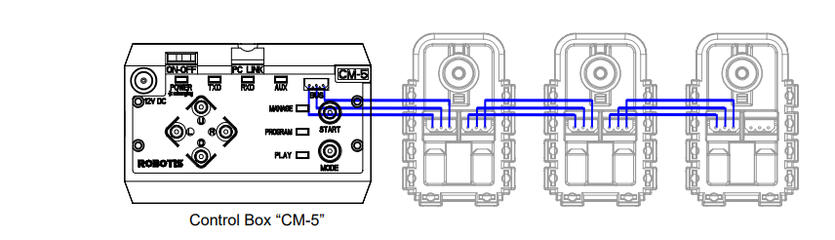

To operate the Dynamixel actuators, the main controller must support TTL level half duplex UART. A proprietary controller can be used, but the use of the Dynamixel controller CM-5 is recommended.

**Connection to UART :-**

To operate the Dynamixel actuators, the main controller must support TTL level half duplex UART. A proprietary controller can be used, but the use of the Dynamixel controller CM-5 is recommended.

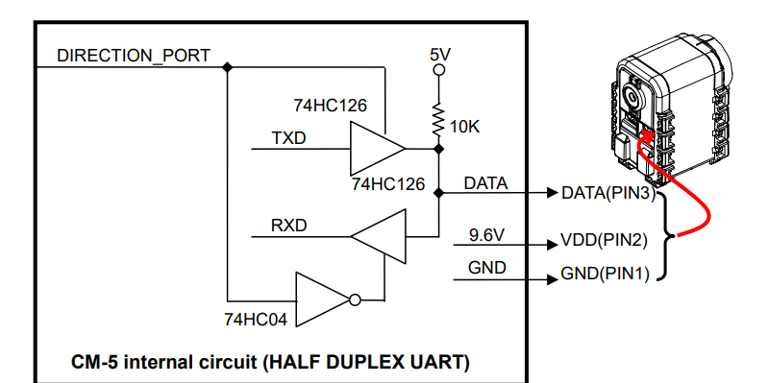

The power is supplied to the Dynamixel actuator from the main controller through Pin 1 and Pin 2 of the Molex3P connector. (The circuit shown above is presented only to explain the use of half duplex UART. The CM-5 controller already has the above circuitry built in, thus the Dynamixel actuators can be directly connected to it) The direction of data signals on the TTL level TxD and RxD depends on the DIRECTION_PORT level as the following.

• When the DIRECTION_PORT level is High: the signal TxD is output as Data

• When the DIRECTION_PORT level is Low: the signal Data is input as RxD

**Half Duplex UART :-**

Half duplex UART is a serial communication protocol where both TxD and RxD cannot be used at the same time. This method is generally used when many devices need to be connected to a single bus. Since more than one device are connected to the same bus, all the other devices need to be in input mode while one device is transmitting. The Main Controller that controls the Dynamixel actuators sets the communication direction to input mode, and only when it is transmitting an Instruction Packet, it changes the direction to output mode.

A multi-drop method of connecting multiple Dynamixel actuators to a single node is possible by using the half duplex UART. Thus a protocol that does not allow multiple transmissions at the same time should be maintained when controlling the Dynamixel actuators.

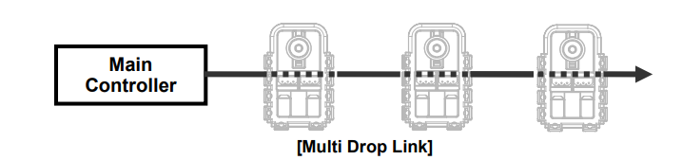

The main controller communicates with the Dynamixel units by sending and receiving data packets. There are two types of packets; the “Instruction Packet” (sent from the main controller to the Dynamixel actuators) and the “Status Packet” (sent from the Dynamixel actuators to the main controller.)

If multiple Dynamixel units have the same ID value, multiple packets sent simultaneously collide, resulting in communication problems. Thus, it is imperative that no Dynamixel units share the same ID in a network node.

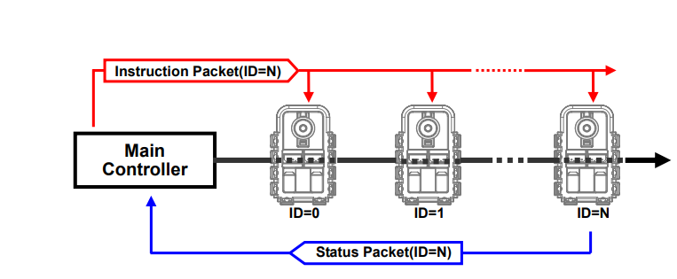

**Electronic Assembly :-**

The photo of the PCB designed in this system is as follows :-

(1) TOP VIEW

(2) BOTTOM VIEW

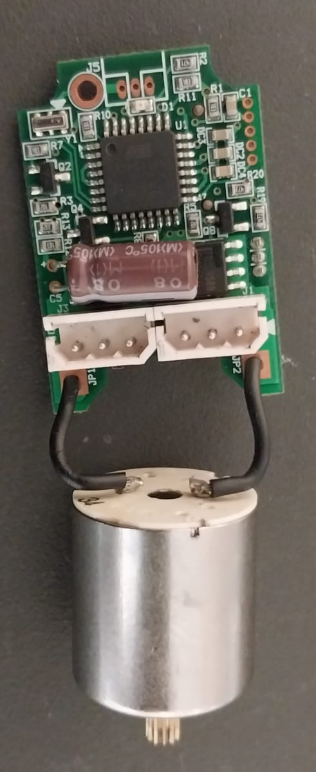

(1)

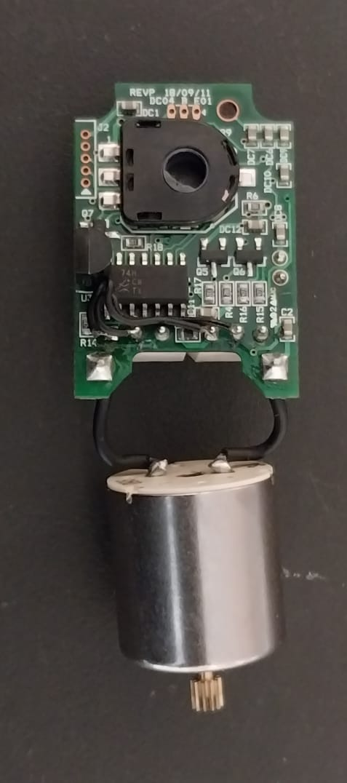

(2)

List of Components :-

|  |  |
| --- | --- |
| 100nF ceramic capacitor | 4 |
| 4.7UF SMD CAPACITOR | 2 |
| 10pF SMD CAPACITOR | 2 |
| 4.7UF 25V DECOUPLING CAPACITOR | 1 |
| 2.2OHM SMD RESISTOR | 2 |
| 10KOHM SMD RESISTOR | 4 |
| ATMEGA8A-AU | 1 |
| FDS 8958B MOSFET IC | 2 |
| 74HC126 BUFFER IC | 1 |
| JST 3PIN CONNECTOR | 2 |
| 78M05 (7805 VOLTAGE REGULATOR SMD VERSION) | 1 |
| 8MHz CRYSTAL OSCILLATOR (XT1) | 1 |
| RDC501051A POTENTIOMETER | 1 |

The detailed Description of the use of the mentioned components can be identified and bitterly understand after analyzing the Schematics of this circuit which is shown in next page.

The schematic was made in the open source PCB designing platform EASY EDA. The considerations for the schematic designing is as follows:-

1. Project Requirements and Specifications

Define the purpose and specifications of the PCB. Understand what the board needs to do, the components it will include, power requirements, signal types, and any size or form factor constraints.

2. Block Diagram

Create a block diagram to visualize the major functional blocks and their interconnections. This will help you organize your design and understand the flow of signals.

3. Component Selection

Choose appropriate components based on their specifications, availability, cost, and compatibility with the overall design. Consider factors such as voltage ratings, current ratings, package sizes, and lead spacing.

4. Software working

Familiarize yourself with the schematic capture software you'll be using. Different software tools have their own interfaces and features, so understanding how to use them efficiently is essential. Easy EDA is the open source and user friendly Software which has its tutorial playlist on Youtube.

5. Power Distribution

Plan the power distribution carefully. Ensure proper power supply connections, decoupling capacitors, and ground connections to minimize noise and ensure stable operation.

6. Signal Integrity

Consider signal integrity early in the design process. Route sensitive analog signals away from noisy digital signals, use proper trace impedance for high-speed signals, and avoid signal reflections and crosstalk.

7. Component Placement

Strategically place components on the schematic to minimize trace lengths and optimize signal paths. Group related components together for better organization.

8. Design Reusability

When possible, design circuits in a modular and reusable manner. This can save time in future projects by allowing you to reuse proven circuit blocks.

9. Documentation and Labels

Properly label components, nets, and important nodes on the schematic. This will make it easier to understand the design and troubleshoot issues later.

10. Footprint Compatibility

Ensure that the chosen components have corresponding footprints in your PCB design software's library. Components and footprints should match to prevent layout issues.

11. Design Constraints

Be aware of any specific design constraints, such as size limitations, manufacturing capabilities, and assembly requirements, which might affect your design decisions.

12. Design Rule Check (DRC)

Most PCB design software includes a DRC feature that checks your schematic against predefined rules. Running a DRC can catch errors and inconsistencies before you move on to PCB layout.

13. Future Expansion and Modifications

Consider possible future modifications or additions to the design. Leave room for expansion and make sure the design can accommodate changes without major disruptions.

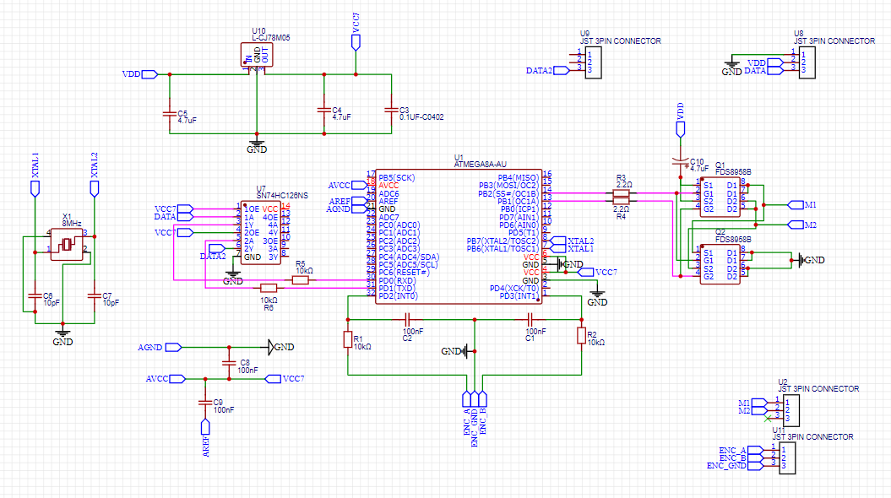

Particularly for this schematic every components used is properly labeled with its name.

The description of the components used and every protection circuit is used is as follows :-

**ATMEGA8A-AU:-**

ATMEL ATmega8A-U PDIP-28 Microcontroller from Atmega8A family is a high-performance, low-power Atmel 8-bit AVR RISC-based microcontroller combines 8KB ISP flash memory, 1KB SRAM, 512B EEPROM, a 7-channel/10-bit A/D converter (TQFP and QFN/MLF), and debug WIRE for on-chip debugging. The device supports a throughput of 16 MIPS at 16 MHz and operates between 4.5-5.5 volts.

By executing powerful instructions in a single clock cycle, the device achieves throughputs approaching 1 MIPS per MHz, balancing power consumption and processing speed.

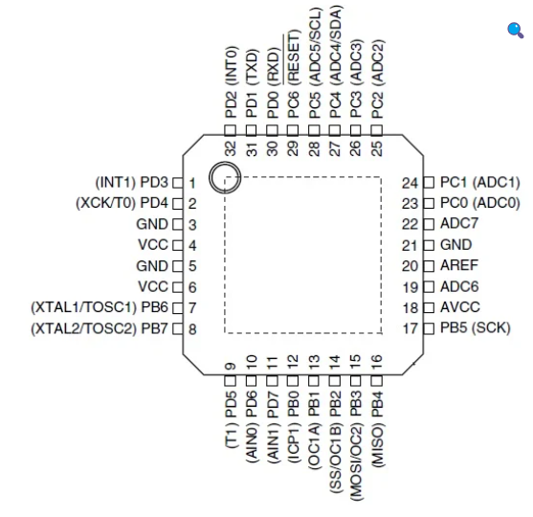

This is the main controller which generates the PWM signal which controls the motor speed.

It interprets the data from DATA pin and also consider the encoder position and generates the PWM signal accordingly on pin 13(OC1A) and 14(OC1B).

For the Daisy chain connections , it will verify the signal from data pin , verify it and if it is not valid then it will transmit to the Data pin of another device which is connected with it in daisy chain .

**2. FDS8958B MOSFET IC :-**

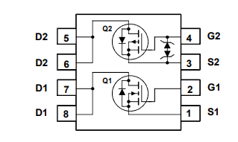

It is a dual N & P-Channel Power Trench type MOSFET.

Q1-N-Channel: 30 V, 6.4 A, 26 mΩ

Q2-P-Channel: -30 V, -4.5 A, 51 mΩ

Using this MOSFET the H- BRIDGE is made which can control the dc motor having stall torque of 18 Nm[12V , 2.2 A].

This MOSFET need a source of 12V so we have connected the VDD pin (External power pin in JST Connector) with a 4.7UF decoupling capacitor for protection and proper continuous supply.

**3. 74HC126 BUFFER IC :-**

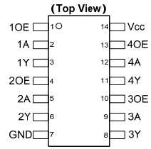

74HC126 provides provides four independent buffer gates with 3-state outputs. Each buffer has a separate enable pin that if driven with a low logic level places the corresponding output in the high impedance state. The device is designed for operation with a power supply range of 2.0V to 6.0V.

This IC is used to store the data temporarily when the data is received or transmitted from RxD pin or TxD pin in the Atmega 8A.

It holds the bit until the microcontroller will verify the unique ID by the other peripherals.

Similarly it will hold the data while transmitting the data to another device in daisy chain.

**4. L-CJ78M05 :-**

It is the SMD version of the 7805 voltage regulator.

It regulates the 12V power supply from VDD pin to the microcontroller compatible 5V power supply.

The capacitor assembly used with this IC for the protection and maintaining the proper supply for the device.

**5. 8MHz Crystal Oscillator :-**

It is used to provide the clock cycle to ATMEGA 8A microcontroller.

It is given to the XTAL1 & XTAL2 pin of the microcontroller.